banner with apples and crayons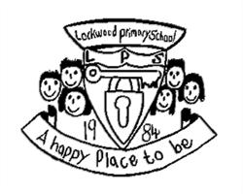

Lockwood Primary School Newsletter

# Dear Parents/Carers

Monday 21st March

**Open Afternoon**

School will be open on Monday 4th April from 3:00 - 4.30pm for you to see your children’s work and if you would like to have a quick chat with your child’s class teacher. This is an opportunity for your children to talk you through the work in their books and to share what they are most proud of.

**Food Bank Assembly**

We had a visit from Robert Dring, a volunteer at Brotton Foodbank, where the food we harvested in the Autumn went. He came into school to thank the children for their donations. He said ours was the largest donation they have ever had. He answered lots of questions from the children and when asked what time of year do they need most donations he said Easter. So perhaps we will make our collection for the foodbank an annual event with a collection next Easter.

What a wonderful idea from the school council to ‘pay to play’. The children had a lovely afternoon playing all sorts of board games brought in from home and some played outdoor games. They then had a comedy corner. Eden Langley from Y5 won a £10 voucher for B & M for the best overall joke.

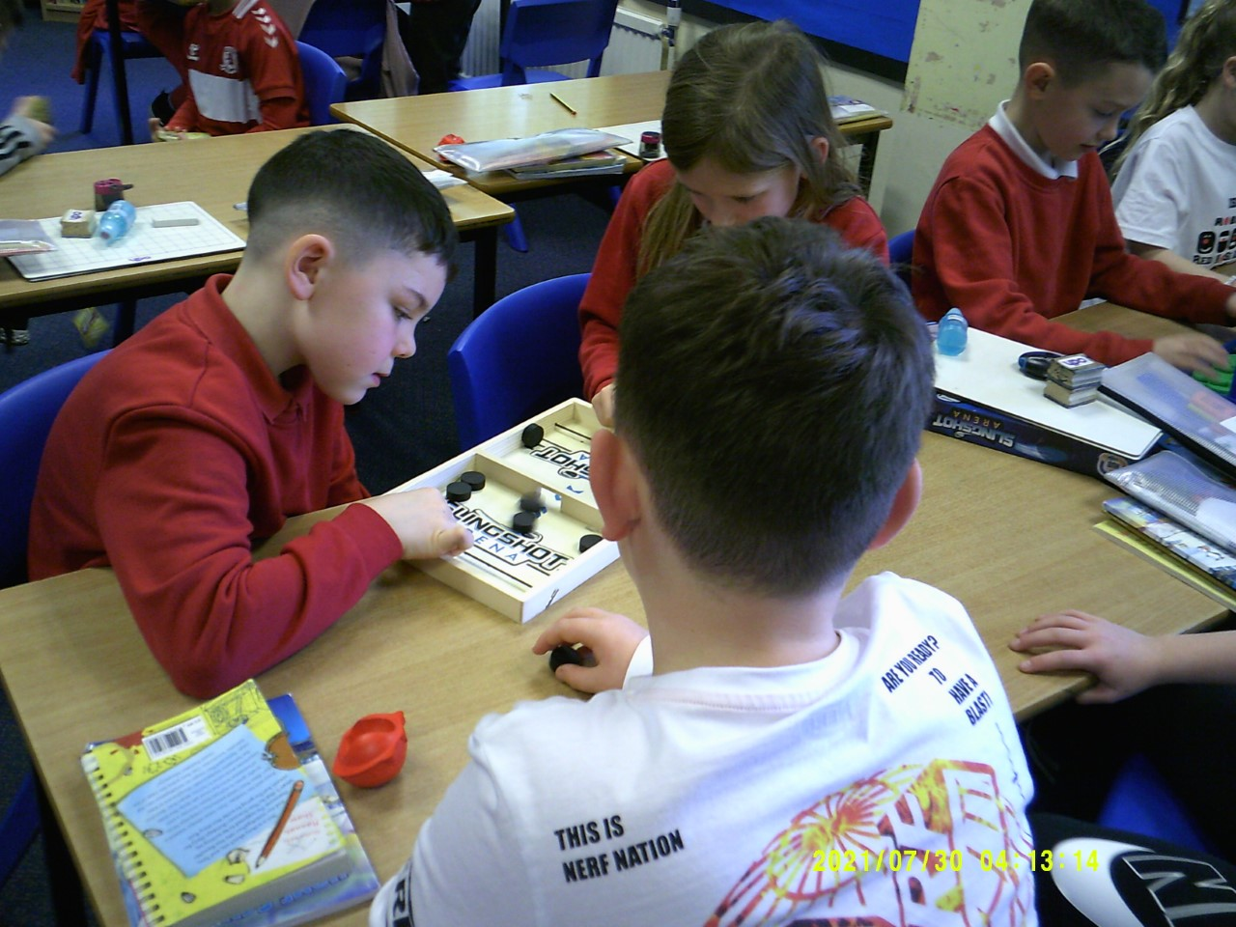

**Red Nose Day Tally** We managed to raise a total of £236.05 selling Red Noses added to our 50p donations to ‘Pay to Play’.

banner with apples and crayons

**Easter Celebrations**

All classes will have an opportunity to make some Easter cards and possibly some craft in the last week of term.

We are running a random number raffle with numbers from 1 upwards (lets see how many we can sell) and children will be invited to buy a number. Miss Langley will allocate numbers in order of purchase. A random number generator will then select who wins the Easter Eggs that have been donated. We have 6 eggs and 2 packs of Kinder Eggs so far, so 8 prizes!

I’m sure we will have even more by this Friday. Numbers will be on sale at morning break from Monday 28th March onwards.

**Easter Egg Hunt**

On Friday 8th April all classes will have an Easter Egg hunt organised by our newly re-established PTA. This will be free.

**Coffee and Cake**

On the same afternoon we would like to offer coffee and cake from 2-3pm.

This is of course dependent on donations of cake! We would love to taste your home baking and maybe some Easter Nests! Please do not send donations before 8th April!

**Times Table Rockstars**

Our first set of awards were given today for the children putting massive effort into improving their ‘rock status’.

Well done to:

Connie Reed  
Jacob Smith and

Joshua Smith



**Numbots Stars**

In KS1 children off to a roaring start on Numbots were:

Marcus Sleeman

Enid Boffey and

Noah Bentley

**Lockwood Primary School Newsletter**

banner with apples and crayons

Lockwood Primary School

Newsletter

**Headteacher’s Award**

Reception: Willow

Year 1: Dolcie-Elise

Year 2: Maggie  
Year 3: Noah

Year 4: Evan  
Year 5: Umayyah  
Year 6: Ruby

**Stars of the week**

Reception: Marcie

Year 1: Ollie

Freddie

Year 2: Jak

Harry  
Year 3: Bradley

Mia R

Year 4: Imogen

Ava

Year 5: Rowan

Sophia  
Year 6: Arthur

Heidi

The attendance award this week goes

To Year X with xx%

Well done!

Mrs Lawson



**House Points to date:**

Red: 676

Yellow: 675

Blue: 509

Green: 507